Finding Inner Stillness

An Experiential Exploration
following leads given in
Advice & Queries 1 & 3

Dolobran Meeting House

Thursday 30th May 2019

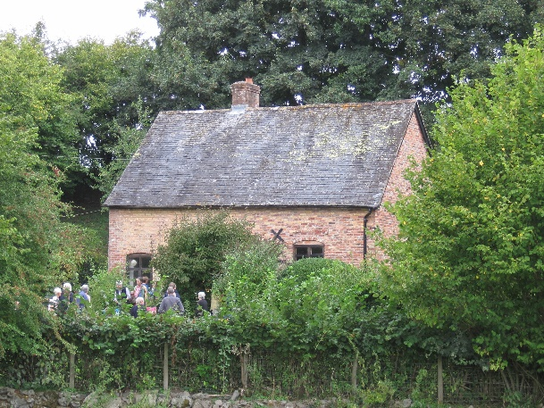

10.00 am for a 10.30 am start
Please bring packed lunch - tea / coffee / biscuits provided
Finishing 4.30 pm
Suggested donation £5 on the day to Dolobran Meeting House
Dolobran Meeting House is off the Meifod via A495 to Pontrobert Road
Grid ref. SJ124124
For directions and access details see separate document

